**ASSIGNMENT 2.3**

Write a program to implement wordcount using Pig.

Program-**>**Wc.pig

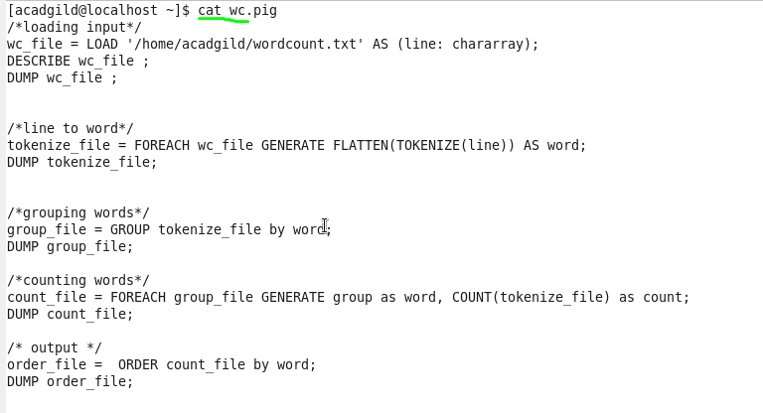

Screenshots of the commands used with its associated output.

Snapshot of input file:

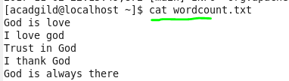

Execution

C:\Users\skm\Pictures\snap\2.3\3.PNG

Output

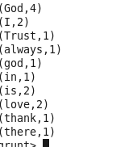

**Step 1**: Loading the input file.

C:\Users\skm\Pictures\snap\2.3\5.PNGC:\Users\skm\Pictures\snap\2.3\6.PNG

**Output**

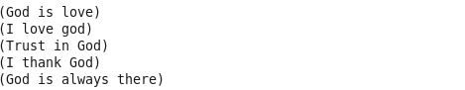

**Step 2:** Converts line to tokens using TOKENIZE and then to words using FLATTEN

C:\Users\skm\Pictures\snap\2.3\8.PNG

**Output**

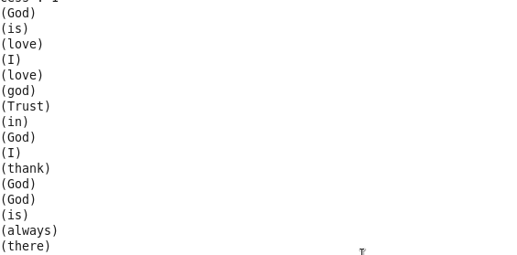

**Step 3:** Group tokenized words

**C:\Users\skm\Pictures\snap\2.3\10.PNG**

**Output**

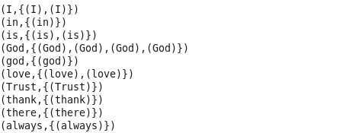

**Step 4:** Count grouped words

C:\Users\skm\Pictures\snap\2.3\13.PNG

**Output**

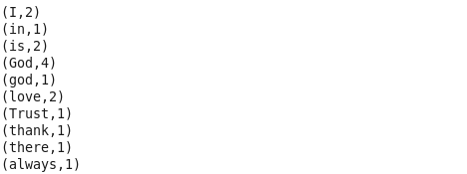

**Step 5:** Order grouped words

C:\Users\skm\Pictures\snap\2.3\15.PNG

**Output**

